Job Available
Lab Assistant
for research on Telecommunication and Cancer Diagnosis
Photonics Laboratory (http://www.photonics.ucla.edu) led by Prof. Bahram Jalali in the Electrical Engineering Department at UCLA seeks an undergraduate or graduate student who can help us in maintaining and recording lab purchase orders; responsibility for documenting equipments and supplies.

A competitive salary is guaranteed.
Knowledge required: proficiency in Excel. Knowledge of editing wiki preferred.

Great potentials to work on exciting research projects, such as cancer diagnosis, silicon photonics, microwave photonics. We encourage applications from students in any discipline.

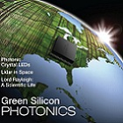
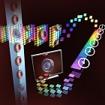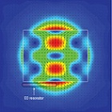
Interested candidates should send a brief e-mail message and resume to Claire Chen (lchen@seas.ucla.edu).

Lab Assistant

lchen@seas.ucla.edu

Lab Assistant

lchen@seas.ucla.edu

Lab Assistant

lchen@seas.ucla.edu
Lab Assistant

lchen@seas.ucla.edu

Lab Assistant

lchen@seas.ucla.edu

Lab Assistant

lchen@seas.ucla.edu

Lab Assistant

lchen@seas.ucla.edu

Lab Assistant

lchen@seas.ucla.edu

Lab Assistant

lchen@seas.ucla.edu

