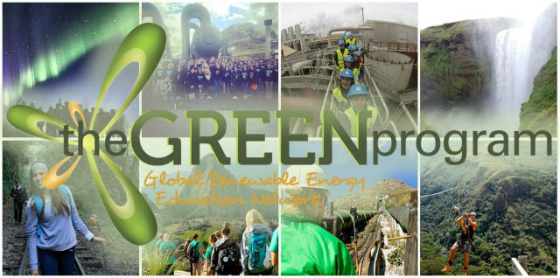
The GREEN Program - Now accepting Applications
The GREEN Program is the premiere experiential learning program for future clean energy and sustainability leaders. The short-term immersion programs take students on adventures to the epicenters of clean tech, sustainability and innovative industries.
- Engage in hands-on, experiential education with industry experts and professionals
- Behind the scenes access to innovative clean energy facilities and sustainability projects
- Supercharge your resume with a global perspective and unique cultural experience
- Network and develop relationships with powerhouse student leaders and professionals
- Bridge the gap between traditional "textbook learning" and real-time industry insight
- World-class "Bucket list" adventure excursions
- Earn transferable credit with a transcript during our 8-10 day programs
Take a step out of the classroom and experience the clean energy and sustainability industries, while having the adventure of your life with The GREEN Program. Be sure to check out program footage from this Summer!

  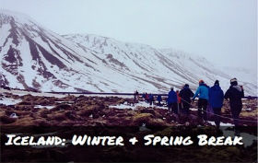
  8-Day Winter & Spring: Renewable Energy + Sustainability + Extreme Climate
  10-Day Summer: Renewable Energy + Sustainability
  - World-class educational environment
  - Bucket list adventure excursions
  - Epicenter of renewable energy
  - Student driven innovation
  - Credit available with transcript
  ​View program vitals Winter & Spring.
  View Program vitals Summer.
  
  9-Day: Sustainable Design + Urban Regeneration + Thought Leadership
  - Crossroads of design and industry
  - Corporate, NGO, and Governmental collaborations
  - Fusion of global markets and sustainability
  - Credit available with transcript
  ​​View program vitals.

  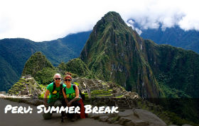
  10-Day: Water Resource Management + Sustainable Practices
  - Explore ancient Inca technologies
  - Evaluate Peru's natural resource policy
  - Implementation of water sanitation technology in the third world
  - Credit available with transcript
  View program vitals.
  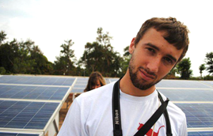
  Casey Heier, Biological Systems Engineering, Stanford University:
  "Every single student who is interested in the environment, renewable energy or sustainability should not hesitate for a second to attend this program. The world needs more GREEN Alumni"
  View Testimonial Archive

Step out of your comfort zone and apply today!

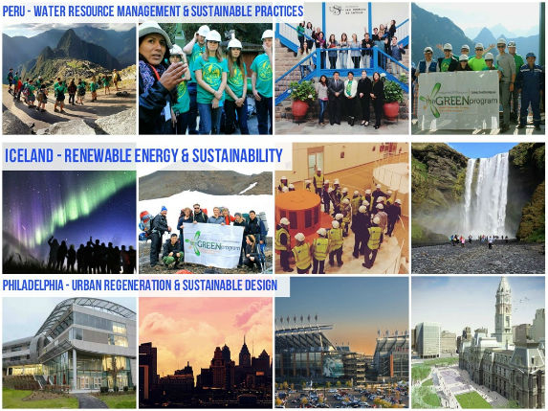
Applications are rolling and competitive, there is not an application deadline. Let this be the year you become a part of a network of student change-makers and innovators. Have a life defining experience.
Apply Today!

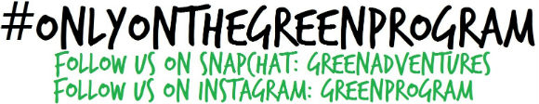

T. Brady Halligan
Director of Strategic Partnerships & Enrollment
brady@theGREENprogram.com
215.796.7860 | theGREENprogram.com

